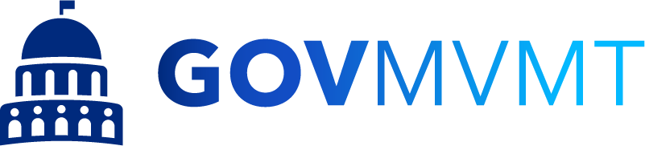

MASTER INTERGOVERNMENTAL COOPERATIVE PURCHASING AGREEMENT

This Master Intergovernmental Cooperative Purchasing Agreement (“Agreement”) is entered into by and between those certain government agencies that execute a Lead Public Agency Certificate (collectively, “Lead Public Agencies”) to be appended and made a part hereof and other government agencies (“Participating Public Agencies”) who register to participate in the GovMVMT Purchasing Cooperative on the GovMVMT website (www.govmvmt.org).

RECITALS

WHEREAS, after a competitive solicitation and selection process by Lead Public Agencies, in compliance with their own policies, procedures, rules and regulations, a number of suppliers (each, a “Contract Supplier”) have entered into Master Agreements with Lead Public Agencies to provide a variety of goods, products and services to the applicable Lead Public Agency and the Participating Public Agencies;

WHEREAS, Master Agreements are made available by Lead Public Agencies through GovMVMT Purchasing Cooperative and provide that Participating Public Agencies may purchase Products and Services at the same terms, conditions and pricing as the Lead Public Agency, subject to any applicable Federal laws, local purchasing ordinances and laws of the State of purchase;

WHEREAS, the parties desire to comply with the requirements and formalities of any intergovernmental cooperative act, if applicable, to the laws of the State of purchase;

WHEREAS, the parties hereto desire to conserve resources and reduce procurement cost; and

WHEREAS, the parties hereto desire to improve the efficiency, effectiveness and economy of the procurement of necessary Products and Services.

NOW, THEREFORE, in consideration of the mutual promises contained in this Agreement, and of the mutual benefits to result, the parties agree as follows:

- Each party will facilitate the cooperative procurement of Products and Services.

- The procurement of Products and Services subject to this Agreement shall be conducted in accordance with and subject to the relevant statutes, ordinances, rules and regulations, that govern each party’s procurement practices.

- The cooperative use of Master Agreements obtained by a party to this Agreement shall be in accordance with the terms and conditions of the Master Agreement, except as modification of those terms and conditions is otherwise allowed or required by applicable law.

- The Lead Public Agencies will make available, upon reasonable request, information regarding the Master Agreement which may assist in improving the procurement of Products and Service by the Participating Public Agencies.

- The Participating Public Agency will make timely payments to the Contract Supplier for Products and Services received in accordance with the terms and conditions of the procurement. Payment, inspections and acceptance of Products and Services ordered by the Participating Public Agency shall be the exclusive obligation of such Participating Public Agency. Disputes between the Participating Public Agency and Contract Supplier are to be resolved in accordance with the law and venue rules of the State of purchase unless otherwise agreed to by the Participating Public Agency and Contract Supplier.

- The Participating Public Agency shall not use this Agreement as a method for obtaining additional concessions or reduced prices for similar Products or Services. Master Agreements may be structured with not-to-exceed pricing, in which case the Contract Supplier may offer the Participating Public Agency and the Participating Public Agency may accept lower pricing or additional concessions for purchase of Product and Services through the Master Agreement.

- The Participating Public Agency shall be responsible for the ordering of Products and Services under this Agreement. The Lead Public Agency or any other party shall not be liable in any manner for any violation by the Participating Public Agency, and, to the extent permitted by applicable law, the Participating Public Agency shall hold the Lead Public Agency and any other party harmless from any liability that may arise from the acts or omissions of the Participating Public Agency.

- The exercise of any rights or remedies by the Participating Public Agency shall be the exclusive obligation of such Participating Public Agency.

- This Agreement shall remain in effect until termination by either party giving thirty (30) days’ written notice to the other party. The provisions of the Agreement shall survive any such termination.

- This Agreement shall be effective after execution of the Lead Public Agency Certificate or Participating Public Agency registration on the GovMVMT website, as applicable.

